HW1 Report

Yi Zhao (Zhao.2175), CSE5524

 1. The first generated image will be a gray scale image. The axis('image') scale the image. The imagesc function would display the image in a full range of colors but the colormap('gray') will display the image in the specified color range, which is grayscale. Thus, the first image written into the file will be a grayscaled image. The second image will be displayed in full range of colors.

Input: (gray) output: (gray)

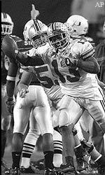 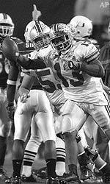

Input: (rgb): output: (rgb)

 

2. The rgb2gray will use Y = .299 R + .587 G + .114 B to change all bits into grayscale.

3. zBlock will create a matrix of 0 with size 10 by 10. Similarly, oBlock will be a matrix of 255 with size 10 by 10. Pattern will be a matrix with size 20\*20, and checkerIm will be the size of 100\*100. The final image will have a size of 100\*100. The first 10\*10 matrix will be all 0, and then for each 10\*10 matrix, the bits will switch between 255 and 0, and so on. The image was shown in grayscale, so all matrix filled with 0 will be displayed as a white square, and a matrix filled with 255 will be black. The image will look like a chess map. Then the rest few lines just do the regular image I/O.

 Output image: (grayscale)

